Golf Performance Analytics System
Final Project
Hayden Leydens
Course: SDEV 220 – Software Development Using Python
August 1, 2026
Introduction
This project was designed for a single golf course to provide a digital application to replace physical scorecards. The Golf Performance Analytics System is a desktop application developed in Python using the Tkinter GUI framework. The purpose of the application is to allow golfers to record every shot during a round, store the results, and review post-round statistics to identify strengths and weaknesses. Unlike a traditional scorekeeping application, this project focuses on organizing shot data and presenting performance metrics after a round has been completed.

Project Objectives
The primary objective of the project was to develop an easy-to-use golf tracking application that demonstrates object-oriented software development principles. The application records individual shots, stores completed rounds using JSON persistence, and provides a post-round analysis screen containing scoring statistics and performance metrics.
Objectives included:
- Recording golf rounds
- Managing golf courses
- Recording individual shots
- Persisting data between sessions
- Providing round analysis
- Creating a graphical interface

System Design

Program Architecture
The Golf Performance Analytics System was designed with a modular, object-oriented architecture that separates the application into: the application controller, the graphical user interface, data models, and data storage. This modular approach promotes code organizations, maintainability, and scalability.

Application Controller (App)
The App class serves as the central controller for the program. It is associated with all GUI screens, with each one calling methods contained in App to delete their current screen or display their current screen. The app class also associated storage manager, and the analytics classes.

Graphical User Interface
The user interface was developed using Python's Tkinter library and is divided into multiple screen classes, each responsible for a single task. Separate screens handle starting a round, entering shots, managing courses, viewing round history, and displaying post-round analysis.

Data Models
The application's core data is represented using object-oriented model classes including Course, Round, Hole, and Shot. These classes are modeled after real-world golf concepts and encapsulate the data and behavior associated with each object.

Storage Manager
The StorageManager class is responsible for loading and saving application data using JSON files. The persistence logic is isolated from the rest of the application.

Analytics
The Analytics class contains the application's statistical calculations. It analyzes completed rounds and generates performance metrics such as total score, score relative to par, birdies, pars, bogeys, putting statistics, penalties, and average scores by hole type.

Overall Design
The overall design of the project was driven by attempting to separate class responsibilities as much as possible. The graphical interface handles user interaction, the models represent golf data, the storage manager manages persistence, the analytics class performs calculations, and the application controller coordinates communication between all components. This modular design improves readability, maintainability, and easily allows for future improvements to be added.

Classes

App
Attributes
storage
current_round
current_course
selected_round
root
current_screen
Methods
show_welcome()
show_manage_courses()
show_start_round()
show_round_entry()
show_round_summary()
show_round_history()
show_round_analysis()
show_hole_scores()
clear_screen()
run()

StorageManager
Attributes
courses
rounds
Methods
load_data()
save_data()
load_courses()
save_courses()
load_rounds()
save_rounds()
add_course()
add_round()
get_courses()
get_rounds()
find_course()

Course
Attributes
name
pars
Methods
to_dict()
from_dict()

Round
Attributes
course
date
holes
current_hole_index
completed
Methods
get_current_hole()
complete_current_hole()
get_total_score()
get_total_putts()
get_total_penalties()
get_course_par()
get_score_to_par()
to_dict()
from_dict()

Hole
Attributes
hole_number
par
shots
completed
Methods
add_shot()
hole_out()
get_score()
get_putts()
get_penalties()
get_next_shot_number()
is_complete()
to_dict()
from_dict()

Shot
Attributes
shot_number
club
shot_type
lie
starting_distance
penalty
notes
Methods
to_dict()
from_dict()
__str__()

Analytics
Methods
total_rounds()
average_score()
best_score()
worst_score()
average_score_to_par()
average_putts()
average_penalties()
score()
score_to_par()
putts()
penalties()
birdies()
pars()
bogeys()
double_bogeys()
triple_plus()
average_par3_score()
average_par4_score()
average_par5_score()

GUI Screens

WelcomeScreen
ManageCoursesScreen
StartRoundScreen
RoundEntryScreen
RoundSummaryScreen
RoundHistoryScreen
RoundAnalysisScreen
HoleScoresScree

UML Class Diagram

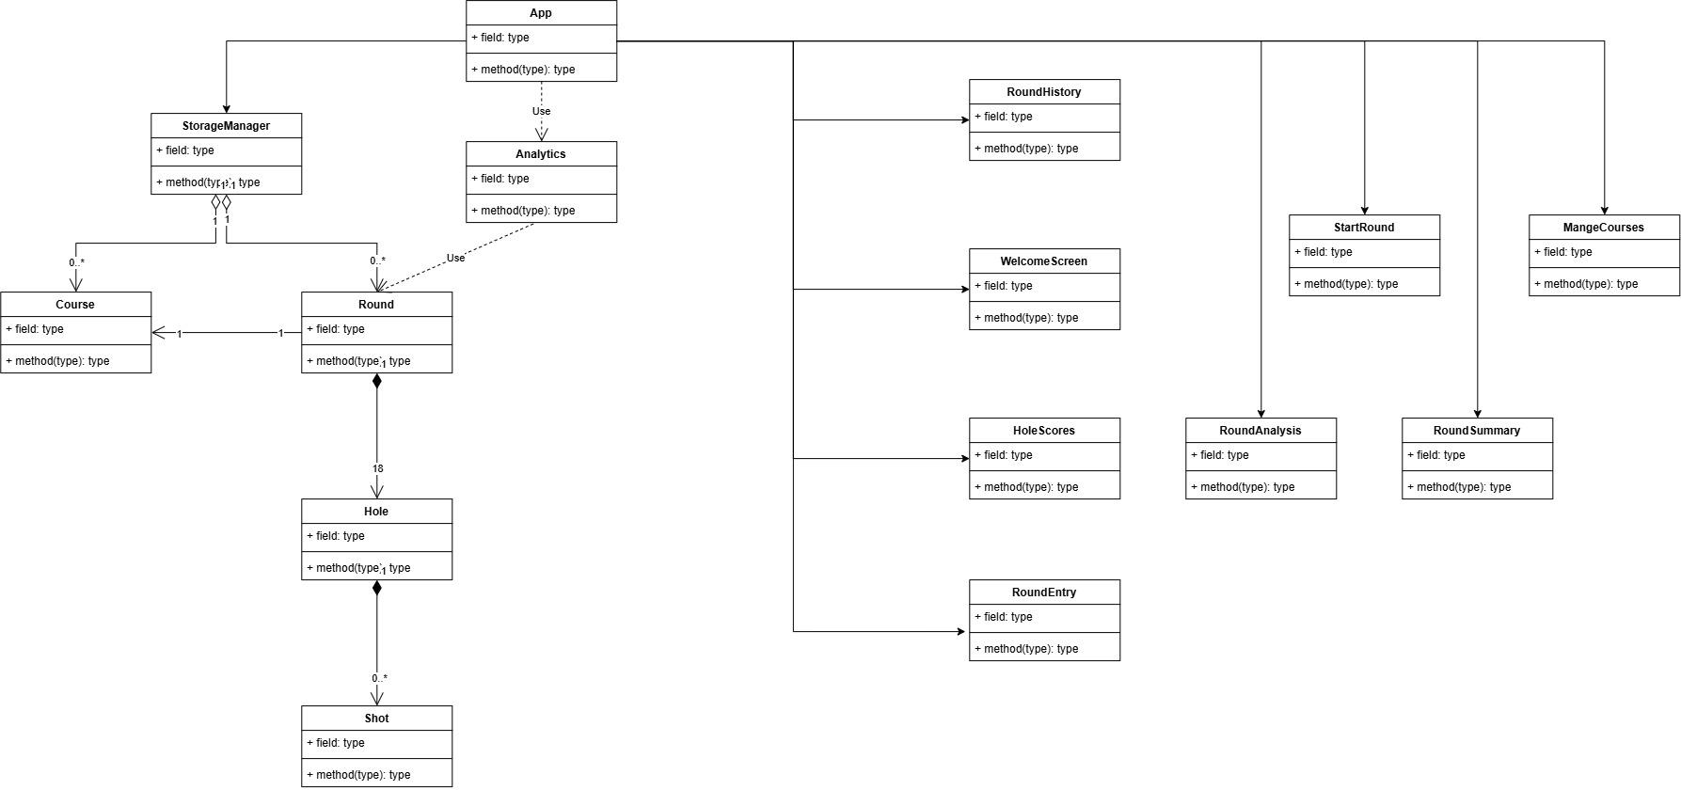

Features

Welcome Screen
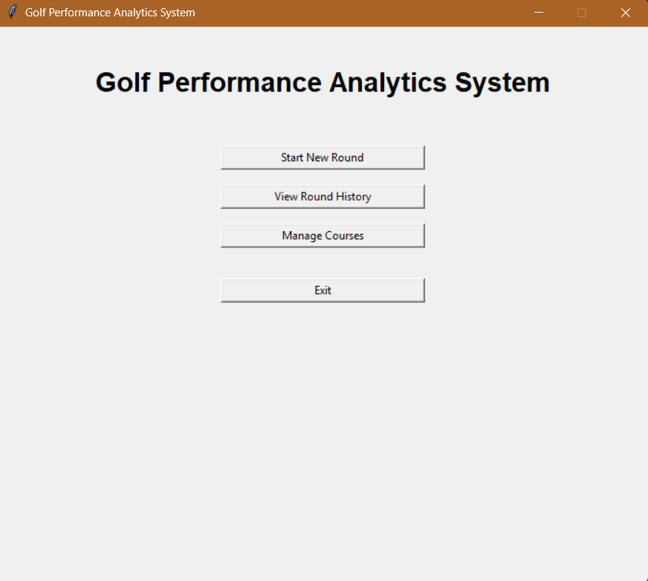

Start Round
3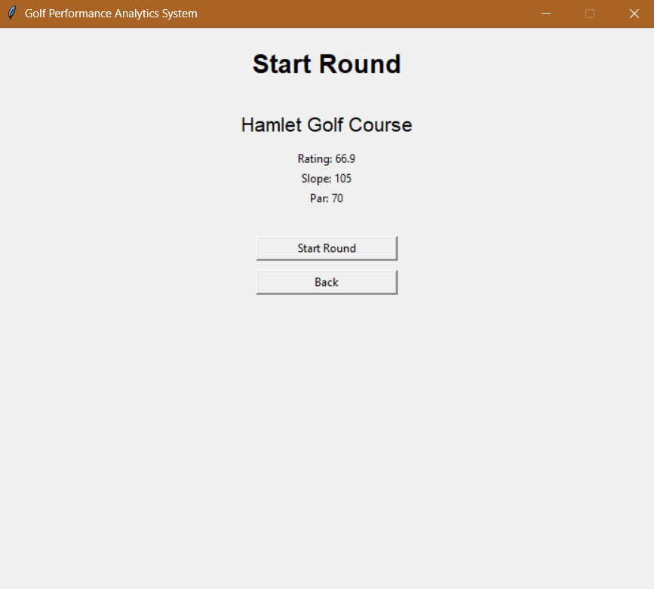

Round Entry
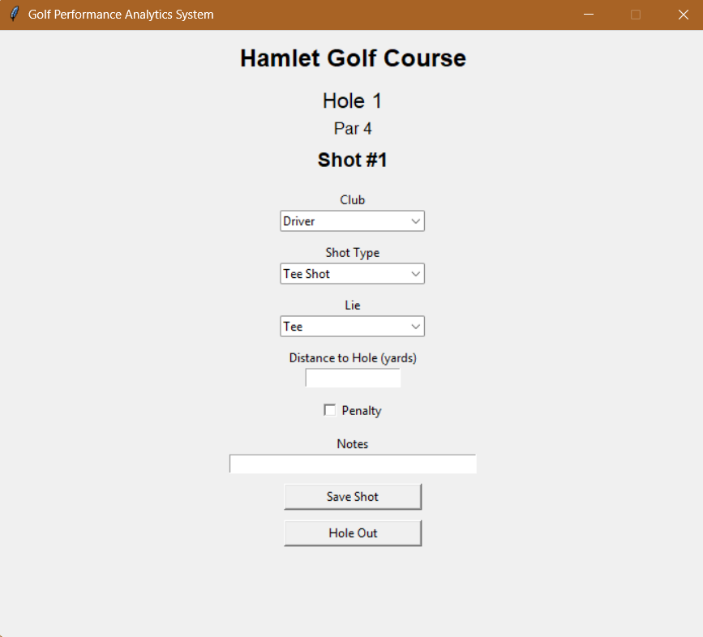

Round History
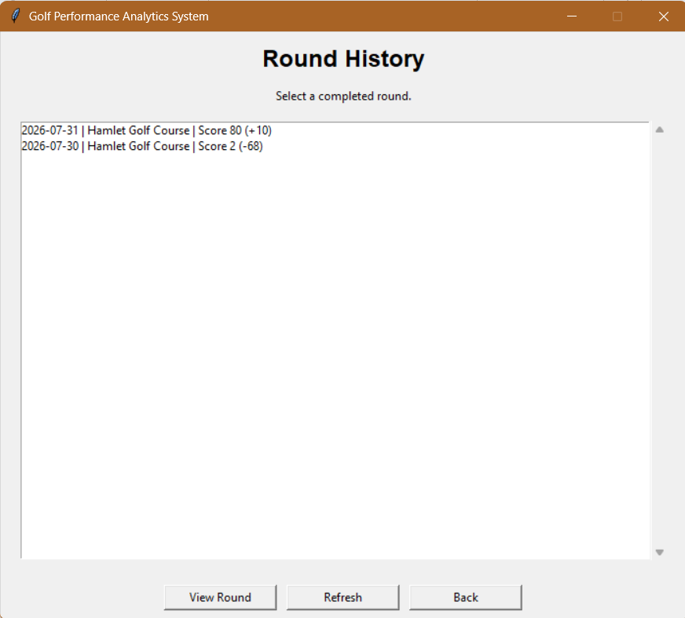

Round Analysis
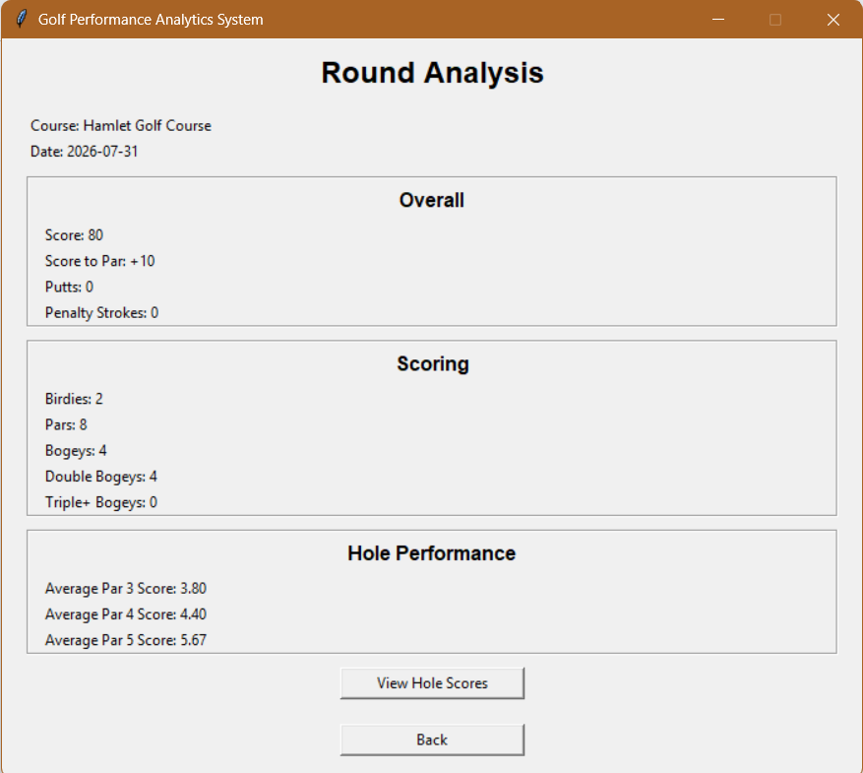

Hole Scores
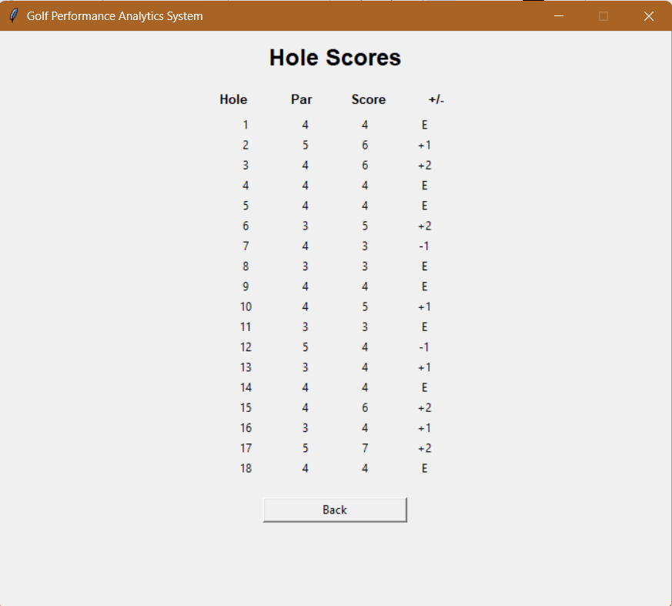

Future Improvements
Possible enhancements include:
- Strokes gained calculations
- Fairways hit and greens in regulation
- Club distance analysis
- Charts and graphs
- Export to CSV
- Multiple golfer profiles
- Handicap calculation
- Course statistics

Conclusion
The Golf Performance Analytics System successfully demonstrates the use of object-oriented programming, graphical user interface development, JSON data storage, and software design principles in Python. The goal of the project was to create an application that allows golfers to record every shot during a round, save that information, and review meaningful statistics after the round is complete. Throughout development, I focused on creating a modular design by separating the user interface, data models, analytics, and storage components into their own classes. This approach made the code easier to organize, test, and maintain while also providing a solid foundation for future enhancements such as additional analytics, strokes gained calculations, and support for multiple golfers.

